**Exercise 1: Implementing the Singleton Pattern**

Logger.java

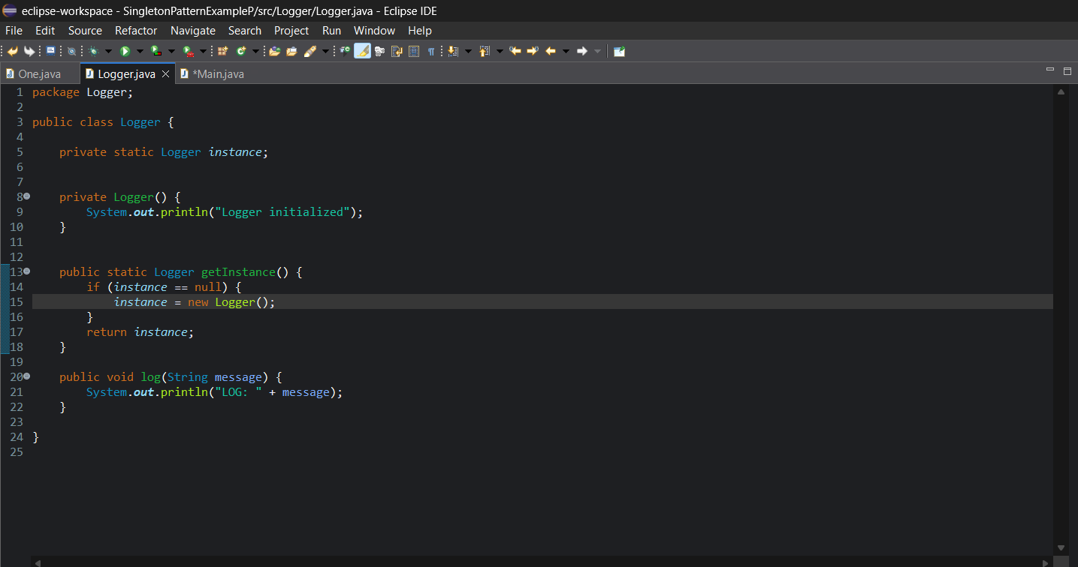

Main.java

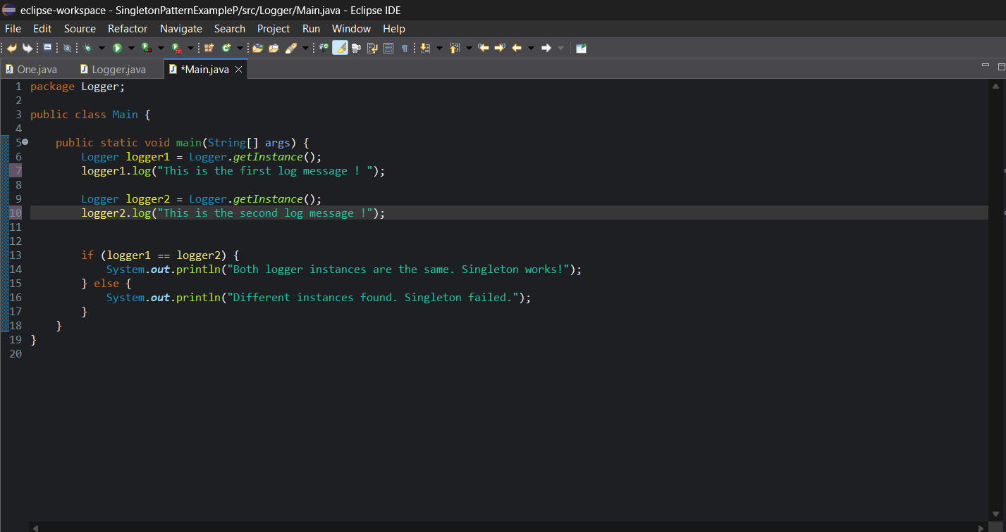

**Output**:   
  
